**Real-Time Multilingual Speech Translation and Communication Enhancement Tool**

Gurupriya M, Department of Computer Science and Engineering, Amrita School of Computing, Bengaluru,

Amrita Vishwa Vidyapeetham, India. [m_gurupriya@blr.amrita.edu](mailto:m_gurupriya@blr.amrita.edu)

Sunkara Sravan , Department of Computer Science and Engineering, Amrita School of Computing, Bengaluru, Amrita Vishwa Vidyapeetham, Karnataka 560035, India, [bl.en.u4cse21203@bl.students.amrita.edu](mailto:bl.en.u4cse21203@bl.students.amrita.edu)

Peddada Gowtham, Department of Computer Science and Engineering, Amrita School of Computing, Bengaluru, Amrita Vishwa Vidyapeetham, Karnataka 560035, India, [bl.en.u4cse21151@bl.students.amrita.edu](mailto:bl.en.u4cse21151@bl.students.amrita.edu)

P Lakshmikanth, Department of Computer Science and Engineering, Amrita School of Computing, Bengaluru, Amrita Vishwa Vidyapeetham, Karnataka 560035, India, [bl.en.u4cse21157@bl.students.amrita.edu](mailto:bl.en.u4cse21157@bl.students.amrita.edu)

**Abstract**

The project presents a language translation tool that uses real-time speech recognition to serve as an effective voice interpreter. It provides a user-friendly interface for smooth cross-language communication and was created in Python using modules like Streamlit, SpeechRecognition, Pygame mixer module and GTTS. The application records spoken audio, converts it into the target language, and outputs text and audio in real time. For improved usability, it also shows both the translated and original input text. This innovation is perfect for multilingual encounters since it guarantees a genuine, human-like translation flow.

**Keywords**

Real-time Translation, Voice Recognition, SpeechRecognition, GTTS, Cross-language Communication, Streamlit Interface, Pygame

1. **Introduction**

This paper offers a voice recognition-based real-time language translation solution that may be used as a virtual interpreter to easily overcome language obstacles. Effective multilingual communication is crucial for multicultural communities, businesses, and tourists as the world grows increasingly interconnected. By listening to spoken words, translating them quickly, and producing audio output in the target language, this tool mimics the precision and fluidity of human translation. It provides an intuitive experience that facilitates immediate cross-language communication by encapsulating the organic rhythm and structure of spoken language.

Built with Python, and with the help of key libraries such as Google Text-to-Speech (GTTS), SpeechRecognition, and Googletrans, this tool makes voice-to-voice translation as simple as possible. The SpeechRecognition module records the audio input and the Googletrans transcribes accurate translation between source and target language. The translated language is immediately spoken by GTTS in order to enable the users to interact in real-time. Also, the interface of the tool is developed using Streamlit, and the users can choose languages and manage the translation process smoothly.

The technical tools of this project ensure reliable and efficient real-time interpretation for various purposes, such as business meetings, travels, and education. Between people who are using different languages the ability to translate the spoken language into the audio output helps to have natural and engaging conversations. Because it helps all to communicate, this tool is not only a help with language barriers but also it is inclusive.

1. **Related Works**

Xian Li et al. [1] This work employs low hyperparameter tuning, pretrained voice and text models to offer an efficient approach to translating multilingual speech into text. The method is based on LayerNorm and Attention (LNA) finetuning which provides satisfactory results in the zero-shot crosslingual setting with as many as only 1–10 % of parameters adapted. The method introduces new state-of-art performance on the CoVoST 2 benchmark, improves the translation quality, reduces training expenses, and decreases the demands on processing power. It does this through the integration of wav2vec 2.0 for speech encoding and mBART for text decoding. Sathish Indurthi et al. [2] The article presents a new concept of extending the data efficiency of the speech-to-text translation technique using the meta-learning strategy for the modality-agnostic. The method applies meta-learning to transfer knowledge from ASR and high-resource MT to low-resource ST. Applying the technique results in a five-fold increase in BLEU scores and sets record-breaking quality in translating selected MuST-C English German as well as English-French tasks. This method gives a robust approach to overcome the problem associated with the unavailability of data in end-to-end speech to speech translation.

Alexei Baevski et al. [3] Describing a self-supervised learning approach for learning speech representations, the work offers a framework for approach for learning representation from raw speech data. To fine-tune the model, parts of the input are occluded, and to enforce the relation between the non-occluded parts of the XML, a contrastive loss is applied. The technique drastically decreases the amount of labelled data needed for speech recognition while producing comparable levels of performance. wav2vec 2.0 brought out its best performance on low resource speech recognition scenarios, after it has undergone pre-training on massive amounts of unlabeled voice data, and stands tall on benchmarks like Librispeech and on TIMIT. Parnia Bahar et al. [4] The findings of this cross-lingual investigation also state the end-to-end voice-to-text translation paradigm efficiency in the speech translation domain. With respect to topologies, it explores distinct topologies and how it is possible to enhance convergence with the assistance of auxiliary connectionist temporal classification (CTC) loss. The authors also consider the effect of pre-training for distinct model components and discover that it could improve the model by approximately 4% in BLEU and 5% in TER. Sanyog Vyawahare et al. [5] In this paper, an experiment is addressed by a chatbot built with the of IBM Watson Assistant tool to support the ESL learners. Some of the functionalities of the chatbot involve text to speech API features like singing lyrics, API for simplification, and API for translation to regional languages. It allows high school students to complete kinetic language tasks while gaining new English knowing no barriers. Sameer Bansal et al. [6] This work proposes a new way of improving ST for low resource languages by fine-tuning the models on vast amounts of ASR data from high resource languages. The researchers do this with just 20 hours of training data and achieve significant improvements in translation accuracy, the BLEU score rising from 10, 8 to 20.2. They discover that the biggest improvements arise from the transfer of the encoder settings via ablation tests from the ASR model. The results presented in the work suggest that it is possible to significantly improve the performance of low-resource ST tasks through the use of ASR data from mismatched languages.

Yuchen Liu et al. [7] The Paper focuses on the future of end-to-end ST models. They include lower latency and less error aeration as compared to the traditional pipeline systems it has a major merit. Drawing on a knowledge distillation concept, the paper presents a novel text translation model that teaches the ST model yielding enhanced performance across English-French and English-Chinese data sets. Anne Wu et al. [8] In this paper, a novel approach of enhancing the end-to-end ST system following knowledge distillation from text translation models is proposed. Combined into one, using voice recognition and translation reduces pipeline latency and error propagation It also speaks about how, as opposed to the standard pipeline systems, utilizing voice recognition and translation in one pipe-line, assists in decreasing latency and error propagation. The experiments prove that the proposed method enhances the ST performance gain by a large margin, especially for both English-French and English-Chinese language pair and proved that the model becomes efficient than the other models in handling similar and dissimilar languages.

Ann Lee et al. [9] the paper builds on recent advancements in speech-to-speech translation (S2ST) by addressing the challenges of data scarcity and the absence of written forms in many languages. It highlights the drawbacks of earlier research that mostly depended on text-to-speech (TTS) systems to produce synthetic target speech (Tjandra et al., 2019; Zhang et al., 2020). Research on actual S2ST data has been made possible by the advent of large-scale datasets such as VoxPopuli (Wang et al., 2021c), and self-supervised learning approaches (Lee et al., 2021) have demonstrated promise in enhancing translation quality in the absence of text annotations. By extending these approaches, this work shows notable performance gains for direct S2ST systems. Xie Chen et al. [10] The paper on speech recognition has evolved significantly, with early works focusing on RNNs and LSTMs, such as the RNN Transducer (RNN-T) which effectively managed latency in automatic speech recognition (ASR). Recent advancements have introduced Transformer-based models, which leverage attention mechanisms for improved performance, as seen in models like the Speech-Transformer and Conformer. This paper builds on these foundations by proposing a streaming Transformer Transducer that integrates chunk-wise processing to optimize real-time speech recognition on large datasets.

1. **Methodology**

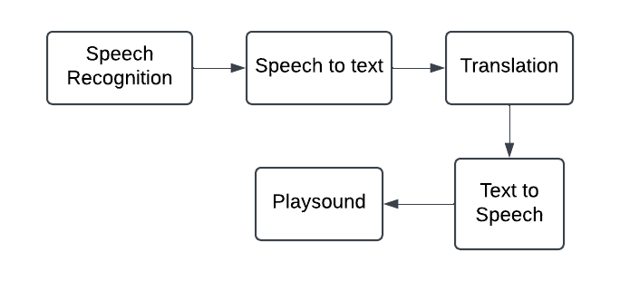

**Fig.1 Flowchart**

**Fig.2 Architecture**

This is the methodology and Model Architecture of our project on building a Real-Time Multilingual Speech Translation and Communication Enhancement Toolbased on the flow given in the figure 1 and figure 2.

Speech Recognition

This step we used the Speech Recognition module to capture spoken input from the microphone. The module ensures that the user's speech is captured clearly by processing audio input. This lays the groundwork for additional processing by enabling the system to operate in real-time.

Speech to Text

In this step the Google speech recognition API is used to turn the recorded audio into text. This API identifies patterns in the audio to give reliable transcription. The translation process is then carried out using the produced text.

Translation

The transcribed text is translated into the target language using the Googletrans library. The module facilitates smooth cross-lingual communication by identifying the source language and translating it into the selected language.

Text to Speech

In this step the GTTS (Google Text-to-Speech) module is used to turn the translated text back into audio. An audio translation of the original speech is produced in this phase by synthesizing spoken language in the target language.

Playsound

Lastly, the Pygame mixer module is used to play back the created speech to the user. This offers a prompt audio response, facilitating speech-to-speech translation in real time for efficient conversation. And also, the input audio and output audio are shown in text format on the display.

1. **Results and analysis**

By accurately translating spoken words into translated audio output, the real-time voice translation tool proved to be helpful in overcoming language gaps. Testing showed that the SpeechRecognition module reliably captured and transcribed speech, with minor errors occurring mainly due to background noise or heavy accents. Although some subtleties or colloquial idioms might occasionally be overlooked, the Googletrans library offered accurate translations across a number of language pairs. Pygame's audio playback made sure the translated message was delivered smoothly, while GTTS transformed text to speech that sounded natural in the target language. Although additional improvement could enhance performance under different environmental situations, the tool's overall high degree of accuracy and responsiveness made it useful for applications requiring real-time, voice-to-voice translation.

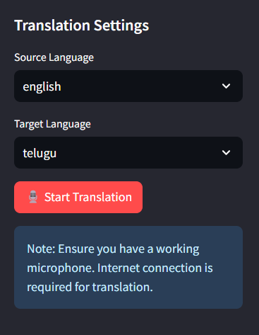

**Fig.3 Speech Recognition**

In Figure 3, the language translator interface allows users to select a source and target language. And then the model is receiving voice input from the user through the SpeechRecognition module that records through the system microphone. This module takes the input and performs real-time text conversion of the spoken words into the subsequent translation. When the user presses the “Start Translation” button, the system starts listening, the state is changed to “Listening…” status, in order to enable the users to communicate effectively for language translation.

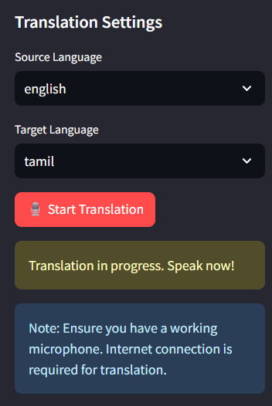

**Fig.4 Speech to text**

In Figure 4, the model is performing the text input processing by converting the captured voice input into text through Google Speech Recognition API. This step involves analyzing the recorded audio and accurately transcribing it into written text form. The "Processing..." status shows that the system is in the process of converting the spoken words, and arranging them for the translation part.

**Fig.5 Translation**

Figure 5, shows how the googletrans library is used to translate text input from the original language intothe destination language. The translated text is then converted into an audio file using Google Text-to-Speech (gTTS). Finally, the audio output is played back to the user using the pygame module, providing an interactive and auditory translation experience.

1. **Conclusion**

The voice recognition-based language translation tool enables real time conversation across the language divide thus emulating the function of an interpreter. Through using SpeechRecognition, Googletrans, and GTTS, the tool is capable of detecting, translating and voicing the input language into the target language. The system was proved to be effective and convenient that it can be used by the people who need the speedy translation services for their businesses. In the tests, the tool demonstrated its efficacy; however, to improve its stability and functionality in different contexts, it is possible to extend the noise filter and to work with complex syntactic structures. Altogether, the present project reveals that technology is a powerful tool in increasing interlanguage communication and reducing gaps in global communication.

The further development of this voice translation tool is to make the tool capable of translating numerous accents, dialects and other intricacies of languages for a better translation. The inclusion of superior machine learning models in the system could help the system understand contextual meaning and idioms to provide better translations that are culturally sensitive. Furthermore, enlarging the offline capabilities would enhance its usage in areas of poor connection; voice options for the interaction would also be useful. This tool has enormous potential for broader use if it will be incorporated into augmented reality or wearable technology for touchless, real-time translation in areas such as tourism, medicine, and customer relations.

1. **References**

[1] Li, Xian, et al. "Multilingual speech translation with efficient finetuning of pretrained models." arXiv preprint arXiv:2010.12829 (2020).

[2] Indurthi, S., et al. "Data Efficient Direct Speechto-Text Translation with Modality Agnostic Meta-Learning." Proc. ICASSP. 2019.

[3] Baevski, Alexei, et al. "wav2vec 2.0: A framework for self-supervised learning of speech representations." Advances in neural information processing systems 33 (2020): 12449-12460.

[4] Bahar, Parnia, Tobias Bieschke, and Hermann Ney. "A comparative study on end-to-end speech to text translation." 2019 IEEE Automatic Speech Recognition and Understanding Workshop (ASRU). IEEE, 2019.

[5] Vyawahare, Sanyog, and Kaustubh Chakradeo. "Chatbot assistant for english as a second language learners." 2020 International Conference on Convergence to Digital World-Quo Vadis (ICCDW). IEEE, 2020.

[6] Bansal, Sameer, et al. "Pre-training on high-resource speech recognition improves low-resource speech-to-text translation." arXiv preprint arXiv:1809.01431 (2018).

[7] Liu, Yuchen, et al. "End-to-End Speech Translation with Knowledge Distillation." arXiv preprint arXiv:1904.08075 (2019).

[8] Wu, Anne, et al. "Self-Supervised Representations Improve End-to-End Speech Translation." arXiv preprint arXiv:2006.12124 (2020).

[9] Lee, Ann, et al. "Textless speech-to-speech translation on real data." arXiv preprint arXiv:2112.08352 (2021).

[10] Chen, Xie, et al. "Developing real-time streaming transformer transducer for speech recognition on large-scale dataset." ICASSP 2021-2021 IEEE International Conference on Acoustics, Speech and Signal Processing (ICASSP). IEEE, 2021.

[11] S. Thangam, M. Gurupriya, O. Kothari, S. N. Sah, K. P. Shah and K. P. Dharmaraj, "Real Time Accident Alert System in Hilly Region using LoRa Technology," 2024 5th International Conference on Smart Electronics and Communication (ICOSEC), Trichy, India, 2024, pp. 700-706, doi: 10.1109/ICOSEC61587.2024.10722473.

[12] R. K C, S. S K and G. M, "Information Processing of Electronic Medical Records Through Intelligent Smart Contracting and its Future Landscape in Industry 5.0," 2024 5th International Conference on Electronics and Sustainable Communication Systems (ICESC), Coimbatore, India, 2024, pp. 1560-1564, doi: 10.1109/ICESC60852.2024.10690110.

[13] U. Kumaran, M. Gurupriya, H. S. Chinta and A. U. S. Maganti, "AI based Pentest for EHR and Other Health Monitoring Devices," 2024 5th International Conference on Smart Electronics and Communication (ICOSEC), Trichy, India, 2024, pp. 1614-1619, doi: 10.1109/ICOSEC61587.2024.10722070.

[14] T. S, G. M, K. J. Kumar, K. Shreya and L. P. Divakarla, "IoT-Based Smart Gauntlet to Assist Physically Challenged and Fragile Mortals," 2024 7th International Conference on Circuit Power and Computing Technologies (ICCPCT), Kollam, India, 2024, pp. 994-1000, doi: 10.1109/ICCPCT61902.2024.10672908.

[15] B. J. Nandini, M. L. Sahithi, S. G. Harshika, S. Thangam and M. Gurupriya, "Smart Refrigerator for Enhancing User Convenience and Food Management," 2024 Second International Conference on Networks, Multimedia and Information Technology (NMITCON), Bengaluru, India, 2024, pp. 1-8, doi: 10.1109/NMITCON62075.2024.10699055.